User Stories
- As a potential member, I want to be able to create an account so that I can access the platform
- As a registered member, I want to able to easily design my profile page and share profile
- As a registered member, I want to be able to chat and hold private conversations with my friends
- As an administrator, I want to be able to browse registered users and remove users
- As a registered member, I would like to access the platform from my phone through a mobile app
- As a administrator, I want to monitor error logs and potential risks.
User Personas

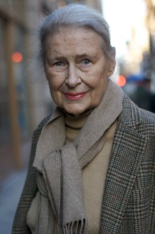  Marge Williams | Detail  71 year old Marge has been divorced for 5 years and has no grandchildren. She lives in a retirement home.  Goal  Would like to connect with her relatives and other retirees.
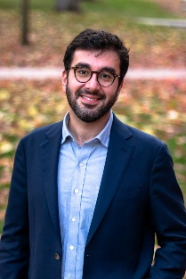  John Hamzinner | Detail  36 year old, John has recently moved into a new condo by himself after recently graduating from UTM.  Goal  Would like to meet new people in the area
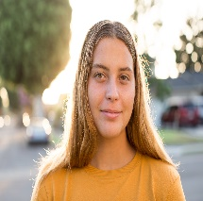  Samantha Robert | Detail  16-year-old, Samantha has moved to a new neighbourhood with her family and will attend her final school years at a nearby high school.  Goal  Would like to make some friends her age in the neighbourhood.

